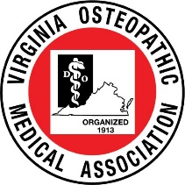
Virginia Osteopathic Medical Association
2023 Fall CME Conference
October 20-22, 2023

Abstract Submission Form
Instructions
- Provide all the requested information below.
- Use Calibri (Body) 11pt font.
- Note that for student and resident led submissions, the abstract must be reviewed and approved by the project mentor. Abstracts not approved by the project mentor will not be accepted.
- Send the completed abstract submission form by e-mail to voma@voma-net.org. Incomplete submission forms will not be accepted.
- All presenters must be registered to attend the VOMA 2023 Fall CME Conference if accepted.
- Abstract submission DEADLINE is September 1, 2023.
- Instructions on poster preparation, printing and display will be sent to authors of accepted abstracts prior to September 20, 2023.
- Posters will be divided into three categories: medical student led, resident led and fellow/physician led.
- IRB approval is required for all research involving human subjects.
Information
Only original research abstracts will be accepted.
Student, Resident and fellow trainees: Has the project mentor reviewed and approved the abstract? Y N
If your research involves human subjects, have you obtained IRB approval ? Y N (please submit approval along with abstract)
Abstract
Title (maximum of 225 characters and spaces total):
Author Names (maximum of 225 characters and spaces total):
Institution/Affiliation (maximum of 225 characters and spaces total):
Abstract body (maximum of 3300 characters and spaces total, or 19 lines of text total):

